Name: ___________________________________ Date: ______________________ Period: _______

**Answer Key**

**Genotypes and Phenotypes**

**Use your vocabulary reference sheet to define the following prefixes and suffixes.**

**different**

**same**

What does ***homo*-** mean? _________________ What does ***hetero*-** mean? _________________

**joined together**

What does –***zygous*** mean? ______________________________________________________________

**The same alleles are joined together.**

Define **homozygous**: ____________________________________________________________________

**Different alleles are joined together.**

Define **heterozygous**: ___________________________________________________________________

**Mammal Traits**

**Plant Traits**



**Insect Traits**

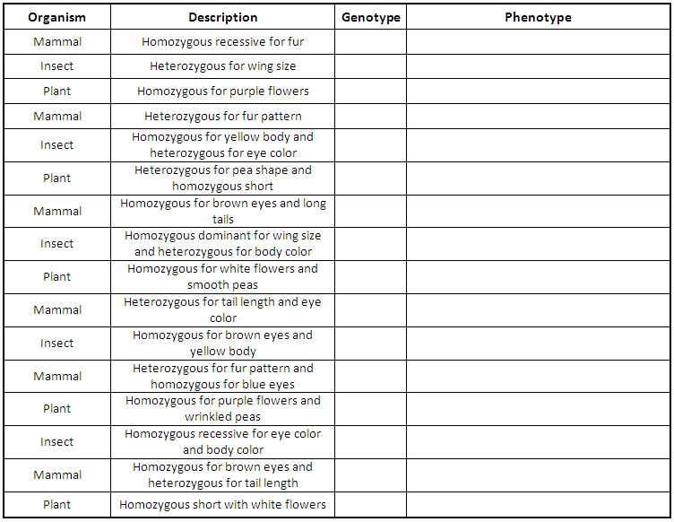

**ff spotted fur**

**Ww large wings**

**PP purple flowers**

**Ff Solid gray fur**

**bbRr yellow body with red eyes**

**Sstt smooth peas and short**

**BBTT brown eyes and long tails**

**WWBb large wings and brown bodies**

**ppSS white flowers and smooth peas**

**TtBb long tails and brown eyes**

**rrbb brown eyes and yellow bodies**

**Ffbb solid gray fur and blue eyes**

**PPss purple flowers and wrinkled peas**

**rrbb brown eyes and yellow bodies**

**BBTt brown eyes and long tail**

**ttpp short with white flowers**

Decide which Punnett square represents both the parents and their offspring. Assume that the offspring shown represent the ratio expected from the Punnett square.

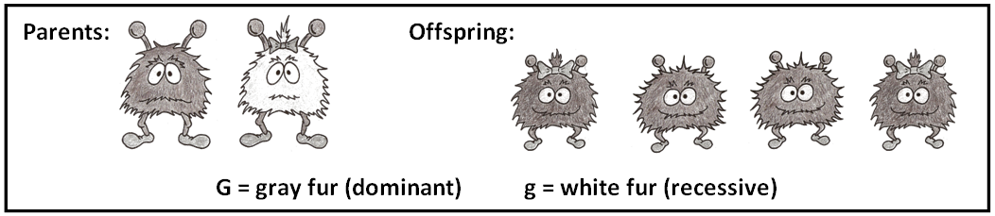

**GG**

**Gg**

**GG**

**Gg**

**G g**

**G**

**G**

**Gg**

**Gg**

**Gg**

**Gg**

**G G**

**g**

**g**

**GG**

**Gg**

**Gg**

**gg**

**G g**

**G**

**g**

**GG**

**GG**

**Gg**

**Gg**

**G G**

**G**

**g**

**B**

**D**

**C**

**A**

**Parent with white fur, all gray offspring**

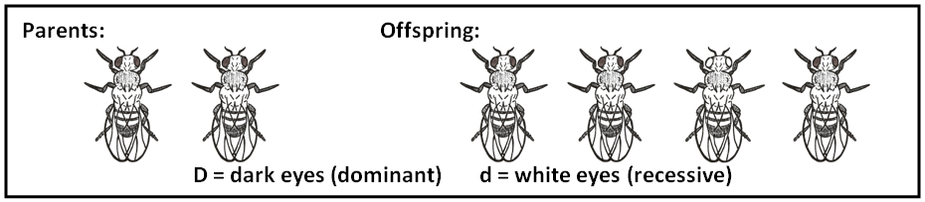

**G**

**F**

**Dd**

**Dd**

**Dd**

**Dd**

**D D**

**d**

**d**

**Dd**

**dd**

**Dd**

**dd**

**D d**

**d**

**d**

**DD**

**Dd**

**DD**

**Dd**

**D d**

**D**

**D**

**DD**

**Dd**

**Dd**

**dd**

**D d**

**D**

**d**

**H**

**J**

**Dark eyes in both parents, possible white-eyed offspring**

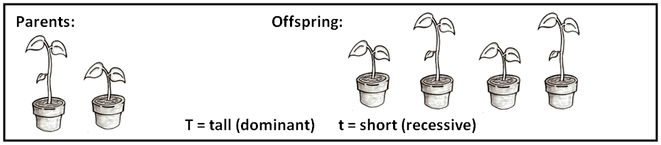

**A**

**Tt**

**tt**

**Tt**

**tt**

**T t**

**t**

**t**

**Tt**

**Tt**

**Tt**

**Tt**

**T T**

**t**

**t**

**TT**

**Tt**

**Tt**

**tt**

**T t**

**T**

**t**

**TT**

**TT**

**Tt**

**Tt**

**T T**

**T**

**t**

**B**

**C**

**D**

**Tall and short parent, with tall and short offspring**

© Haney Science